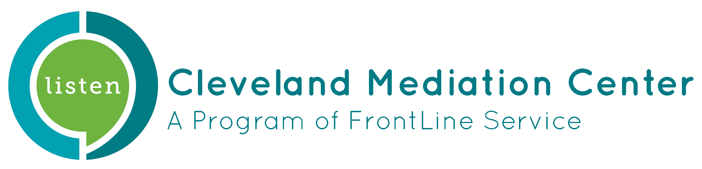

Position: Mediation Intern

Cleveland Mediation Center (CMC) has been mediating disputes and providing conflict resolution and mediation training to the greater Cleveland area since 1981, distinguishing CMC as the first community mediation center in Ohio. We are proud that throughout our history, we have committed to achieving the National Association for Community Mediation’s nine hallmarks of a community mediation center.

CMC promotes just and peaceful community in Northeast Ohio by honoring all people, building their capacity to act, and facilitating opportunities for them to engage in conflict constructively.
​
We fulfill our mission by continuing our work in the community to facilitate dialogue with neighbors, community members, families or other parties, stop evictions, prevent homelessness, improve school attendance, and train those who wish to mediate.

Description: Cleveland Mediation Center seeks an energetic, creative thinker to assist in mediating community and/or court connected cases. This internship is an excellent opportunity to gain experience in mediation while working for an established community based nonprofit organization. The intern will be trained in mediation according to the description below and will also help support the community mediation program. CMC is committed to building and supporting a diverse and inclusive work environment. We encourage people of color, women, and people who identify with other marginalized communities to apply.

Mediation Training:

Interns will be involved in a three part process.

- Training/Orientation
- Attendance at our 3 day Fundamentals of Mediation training is required for interns who wish to mediate (2023 dates May 16th-18th 9:00 am – 5:00 pm each day)
- Orientation and training with CMC staff

- Observation
- Observe CMC staff in mediation and intake

- Practice
- Under the supervision of CMC staff, conduct various mediations within Community Mediation, Landlord Tenant and Shelter Mediation Programs
- The intern will first co-mediate, then mediate on their own
- In order to help interns improve their practice, staff will guide interns through reflective practice, which is an intentional method of analyzing and evaluating one’s thoughts, feelings, and actions prior to, during, and after mediation. This is an important part of learning to become a better mediator and is useful to all mediators regardless of how skilled they are.

Program Support:

The intern will support the Community Mediation Program through fielding phone calls from clients, scheduling, data entry and reporting, administrative office work, and making presentations to promote the program in the community.

Other projects may be explored depending on agency need and the intern’s interest.

Qualifications:
- Completed or working toward a college degree, preferably in a related field (e.g., Communications, Conflict Resolution)
- Be very familiar with computers including working knowledge of Microsoft Suite
- Ability to communicate effectively and work well with co-workers, clients, and community contacts
- Creative thinker, open to collaborate and work independently, interest in conflict resolution, willingness to learn
- Enthusiasm for the mission of Cleveland Mediation Center and the communities we serve
- A commitment to advancing social justice

Compensation: This is an unpaid/volunteer internship.

To Apply: Please send this application with your resume and cover letter to:

Danielle Cosgrove
Danielle.cosgrove@clevelandmediation.org

Intern Application

Contact Information
Name
Address
Phone
Email

Availability | When would you like your internship to begin and end (time frame or school semester(s))?

Why are you applying for an internship at Cleveland Mediation Center?

Please describe your qualifications pertaining to this role.

Person to notify in Case of Emergency
Name |  | Phone

How did you hear about this internship and Cleveland Mediation Center?

Our Policy
Cleveland Mediation Center is an Equal Opportunity Employer. It is our policy to provide equal opportunities without regard to race, sex, age, religious affiliation, national origin, gender identity, gender expression, sexual orientation, ethnic background, citizenship status, marital status, or disability.

Agreement and Signature
I understand that I am applying for a temporary, unpaid internship position at Cleveland Mediation Center.

Signature: ________________________________________ Date: ___________________________

